Our Vision:
To develop aspirational learners who strive for excellence academically, creatively and culturally, benefitting from a wide range of opportunities led by inspirational educators.

Shirley High School
Performing Arts College

Striving for Excellence

Job Description:

Post: Food Technician
Line Manager: Head of Food

Under the direction/instruction of senior staff: provide general support to staff and students, including preparation, and routine maintenance of resources/equipment.

Areas of responsibility and guidance:

Providing daily support for teaching staff:

- Laundry of cloths and tea towels;
- Getting out and putting away ingredients and equipment;
- Cleaning units, sinks, hobs and ovens;
- Checking cupboards and drawers for equipment;
- Supporting Staff in practical lessons;
- Helping to wash-up;
- Clean food rooms;
- Check units are put back properly and washing up is done to a good standard;
- Make sure sinks are clean and dry.

Providing weekly support for teaching staff:

- Bleaching washing up brushes;
- Organising, rotating and cleaning store and equipment cupboards;
- Cleaning refrigerators and rotating stock;
- Maintaining small equipment (e.g. de-scaling kettles);
- Refilling board marker pens;
- Ordering equipment;
- Photocopying as required;

Administration:

- Photocopying as required
- Ordering new equipment
- Putting up wall displays;
- Bookkeeping for budget.
- Computer skills are essential/Microsoft, excel, word.
- A valid Health and Safety Certificate is required when working with food.

Support for the School:

- Being aware of and complying with policies and procedures relating to child protection, health, safety and security and confidentiality, reporting all concerns to an appropriate person;
- Being aware of and supporting difference and ensure all students have equal access to opportunities to learn and develop;
- Contributing to the overall ethos/work/aims of the school;
- Appreciating and supporting the role of other professionals;
- Attending relevant meetings as required;
- Participating in training and other learning activities and performance development as required;
- Occasional class cover supervision for absent staff.

Personal Qualities:

- Reliable and conscientious pastoral leader with high expectations in line with the school;
- Demonstrate great communication skills with all within the school community;
- Neat appearance in line with the school policy;
- Ability to work as part of a successful team and work effectively under pressure;
- Have the determination and resilience to ensure that all students are challenged in all aspects of school life.

Think Green:

- Support the school in demonstrating good environmental practice (such as energy efficiency, use of sustainable materials, recycling and waste reduction) wherever possible in day-to-day work.

Safeguarding and Child Protection:

- To reinforce and enforce the school commitment to safeguarding and promoting the welfare of children and young people.
- Uphold the duty of care to ensure that if there are any concerns relating to the welfare or safety of a child they are immediately relayed to the Designated Person(s) with responsibility for safeguarding children

Essential | Desirable
NVQ 3 or equivalent qualification or experience in relevant discipline | Working knowledge of relevant polices/codes of practice and awareness of relevant legislation
Effective use of ICT and other specialist equipment/resources | Very good organisational skills
Very good numeracy/literacy skills | Ability to relate well to children and adults
Demonstrable attention to detail | Ability to work constructively as part of a team, understanding school roles and responsibilities and your own position within these
Experience of development, management and operation of administrative systems | Ability to self-evaluate learning needs and actively seek learning opportunities

We want all at SHS to believe in and maintain the values of our school:

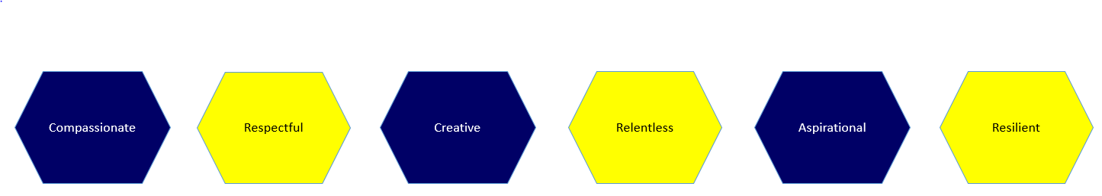

Signature: ……………………………………………………………………… Dated: …………………………………………………….

