Our Vision:
To develop aspirational learners who strive for excellence academically, creatively and culturally, benefitting from a wide range of opportunities led by inspirational educators.

Shirley High School
Performing Arts College

Striving for Excellence

Job Description:

Post: Cover Co-ordinator & HR Administration Assistant
Line Manager: Principal’s PA

Purpose of the Role
To provide an effective and efficient administration of staff absence and other general administration to ensure the smooth running of the school.

Main Areas of Responsibility and Guidance

Administration of Staff Absence:

- Responsible for the administration and co-ordination of the cover programme so as to ensure the smooth running of the school by organising staff to cover absentee teachers’ lessons.
- Complete the cover sheet by 08.10 each morning.
- Display and publish the cover arrangements by 8.15am.
- Utilise the availability of staff in school primarily.
- Maintain accurate records of staff absence and any staff cover.
- Ensure all impending staff absences are recorded and planned for.
- Maintain contact with supply agencies and employ supply teachers as necessary.
- Induct supply teachers and ensure they have the necessary paperwork including DBS checks.
- Maintain financial records of employed supply staff and check invoices prior to submitting for payment.
- Plan for the cover implications of any forthcoming school events.

Absence Management:

- Use SIMS (MIS) to record all staff absences.
- Communicate with absent staff as and when appropriate.
- Check medical certificates and forms are received in relation to staff sickness absence.
- Monitor patterns of absence for all staff to enable the automatic recognition of patterns of absence in accordance with the School’s Management of Sickness Absence Policy.
- To adhere to the sickness management policy and send appropriate letters to staff when trigger points are reached and refer to our Occupational Health provider as appropriate.
- To advise Senior staff on employee absence and long term sickness management and to ensure sickness absence review meetings are arranged as appropriate
- Act as note taker at sickness review meetings
- Provide reports to the Principal and the Senior Leadership Team each term outlining any trends and patterns of absence.
- To liaise closely with all our personnel provider, the Local Authority and other agencies as necessary.
- Any other duties required commensurate with this post.

General Administration:

- Operate efficient administrative and clerical support systems in accordance with approved criteria and resources to meet the needs of the establishment under the direction of the Office Manager
- Carry out basic first aid duties / fire warden responsibilities.
- Contribute to the school’s administrative processes
- Comply with data protection requirements in all working practices and maintain confidentiality as necessary
- Relieving the Receptionist, Reprographics Technician and other administration staff in their absence.
- Carrying out any request by the Principal’ PA as necessary to ensure the efficient running of the Admin Department.

Personal Qualities:

- Reliable and conscientious with high expectations in line with the school;
- Demonstrate great communication skills with all within the school community;
- Neat appearance in line with the school policy;
- Ability to work as part of a successful team and work effectively under pressure;
- Have the determination and resilience to ensure that all students are challenged in all aspects of school life.

Think Green:

- Support the school in demonstrating good environmental practice (such as energy efficiency, use of sustainable materials, recycling and waste reduction) wherever possible in day-to-day work.

Safeguarding and Child Protection:

- To reinforce and enforce the school commitment to safeguarding and promoting the welfare of children and young people.
- Uphold the duty of care to ensure that if there are any concerns relating to the welfare or safety of a child they are immediately relayed to the Designated Person(s) with responsibility for safeguarding children

Essential | Desirable
Good standard of education. GCSE or equivalent | Working knowledge of relevant polices/codes of practice and awareness of relevant legislation
Effective use of ICT and other specialist equipment/resources | Experience or working in a school
Excellent and professional oral and written communication skills | Ability to relate well to children and adults
Accuracy and demonstrable attention to detail | Ability to work independently and constructively as part of a team, understanding school roles and responsibilities and your own position within these
Experience of development, management and operation of administrative systems | Ability to self-evaluate learning needs and actively seek learning opportunities
An understanding of the necessity to maintain confidentiality | Experience of working with SIMs
Enthusiastic and self-motivated | Experience of data collection and presentation

We want all at SHS to believe in and maintain the values of our school:

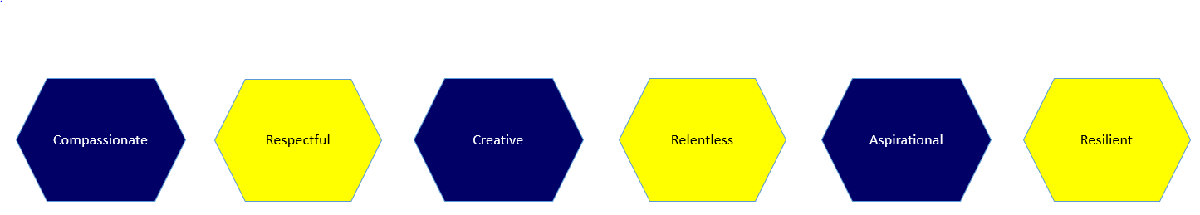

Signature: ……………………………………………………………………… Dated: …………………………………………………….

