Our Vision:
To develop aspirational learners who strive for excellence academically, creatively and culturally, benefitting from a wide range of opportunities led by inspirational educators.

Shirley High School
Performing Arts College

Striving for Excellence

Job Description:

Post: Kitchen Porter
Line Manager: Catering Manager

Under the direction/instruction of senior staff: to assist the Catering team to deliver the highest possible standard of food service to students, staff and visitors and ensure the kitchen is clean, tidy, safe and hygienic.

Areas of responsibility and guidance:

Duties:

- Thorough cleaning of designated areas, sweeping and mopping of floors and ensuring that all kitchen appliances and surfaces are hygienically cleaned;
- Organising and washing pots, pans, small kitchen equipment, cooking utensils, food storage containers, plates and cutlery;
- Unloading deliveries;
- To report premises/equipment repairs and maintenance issues to the Catering Manager;
- To ensure lights and other equipment are switched off as appropriate;
- Removing and recycling waste from the kitchen;
- Attending training sessions/staff briefings as required, possibly outside usual working day;
- Ensuring Health & Safety and Food Hygiene regulations are implemented;
- Working effectively with colleagues as part of a team;
- Promoting the service in the school and participating in special events;
- To ensure the uniform provided by the school is kept clean and tidy and worn at all times whilst at work;
- Carrying out any request by the Catering Manager as necessary to ensure the efficient running of the school kitchen and other duties as may be reasonably required.

Support for the School:

- Being aware of and complying with policies and procedures relating to child protection, health, safety and security and confidentiality, reporting all concerns to an appropriate person;
- Being aware of and supporting difference and ensure all pupils have equal access to opportunities to learn and develop;
- Contributing to the overall ethos/work/aims of the school;
- Appreciating and supporting the role of other professionals;
- Attending relevant meetings as required;
- Participating in training and other learning activities and performance development as required;
- Occasional class cover supervision for absent staff.

Personal Qualities:

- Reliable and conscientious pastoral leader with high expectations in line with the school;
- Demonstrate great communication skills with all within the school community;
- Neat appearance in line with the school policy;
- Ability to work as part of a successful team and work effectively under pressure;
- Have the determination and resilience to ensure that all students are challenged in all aspects of school life.

Think Green:

- Support the school in demonstrating good environmental practice (such as energy efficiency, use of sustainable materials, recycling and waste reduction) wherever possible in day-to-day work.

Safeguarding and Child Protection:

- To reinforce and enforce the school commitment to safeguarding and promoting the welfare of children and young people.
- Uphold the duty of care to ensure that if there are any concerns relating to the welfare or safety of a child they are immediately relayed to the Designated Person(s) with responsibility for safeguarding children

Essential | Desirable
Understanding of hygiene procedures, H&S and Food hygiene regulations | Basic Food Hygiene Certificate  (or a willingness to train)
Ability to carry out tasks quickly and still remain calm under pressure | Experience within a similar role
Use and clean catering equipment and machinery | Experience of working within a school environment in a similar role
Good communication skills
Ability to use own initiative and work as part of a team
Display a commitment to the school’s equality policies

We want all at SHS to believe in and maintain the values of our school:

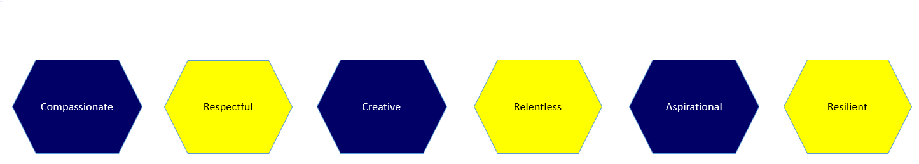

Signature: ……………………………………………………………………… Dated: …………………………………………………….

