

*Our Vision:*

*To develop aspirational learners who strive for excellence academically, creatively and culturally, benefitting from a wide range of opportunities led by inspirational educators.*

**Shirley High School**

**Performing Arts College**

***Striving for Excellence***

**Job Description:**

Post: Head of Year

Line Manager: SLT in charge of behaviour

**Areas of responsibility and guidance:**

* To be responsible for supporting the academic learning and promoting the personal development and welfare of students within a year group.
* To monitor the pastoral and academic performance of students within a year group.
* To help create and maintain a positive learning environment within a year group.
* To have responsibility for issues of attendance, behaviour, commitment and general student welfare, within a year group.
* To lead and manage a team of tutors through whom students will be encouraged to achieve their full potential.
* To liaise with and support Heads of Department in raising levels of achievement and behaviours of students within the year group.
* To promote the whole school pastoral ethos of entitlement and inclusion.
* To use the data information systems, in liaison with tutors, subject teachers, other middle leaders and members of the SLT to monitor, evaluate and review the pastoral and academic progress of students within the year.
* To complete a Year Group Improvement Plan annually and review the success criteria termly
* To role model the schools vision, values and high expectations through the work undertake with the year group
* To establish and foster a strong and supportive identity among tutors and students of the year group;
* To support the school polices and expectations;
* To deliver engaging and inspirational assemblies;
* To identify and target those students that need greater additional support, including the support of external agencies;
* To initiate, review and evaluate the Behaviour Support Plan process for identified students, and keep accurate records of impact
* To manage and monitor a team of form tutors;
* To publicly celebrate achievements;
* To organise and support parental events and evenings;

**Personal Qualities:**

* Reliable and conscientious pastoral leader with high expectations in line with the school;
* Demonstrate great communication skills with all within the school community;
* Neat appearance in line with the school policy;
* Ability to work as part of a successful team and work effectively under pressure;
* Have the determination and resilience to ensure that all students are challenged in all aspects of school life.

**Think Green:**

* Support the school in demonstrating good environmental practice (such as energy efficiency, use of sustainable materials, recycling and waste reduction) wherever possible in day-to-day work.

**Safeguarding and Child Protection:**

* To reinforce and enforce the school commitment to safeguarding and promoting the welfare of children and young people.
* Uphold the duty of care to ensure that if there are any concerns relating to the welfare or safety of a child they are immediately relayed to the Designated Person(s) with responsibility for safeguarding children

|  |  |
| --- | --- |
| Essential | Desirable |
| Qualified Teacher Status | Graduate status in subject are or related subject |
| True commitment to high standards | Experience of 11-18 education |
| Track record of improving student performance | Additional teaching qualifications or training |
| Strong classroom management skills | Sound knowledge of current educational developments, including the use of IT |
| Relentless drive for student and personal progress and success | Ability to teach Key Stage 5 |
| Passion for learning and inspiring others | Strong analytical skills with regards leadership and getting the best out of colleagues |
| Respect for all |  |

We want all at SHS to believe in and maintain the values of our school:

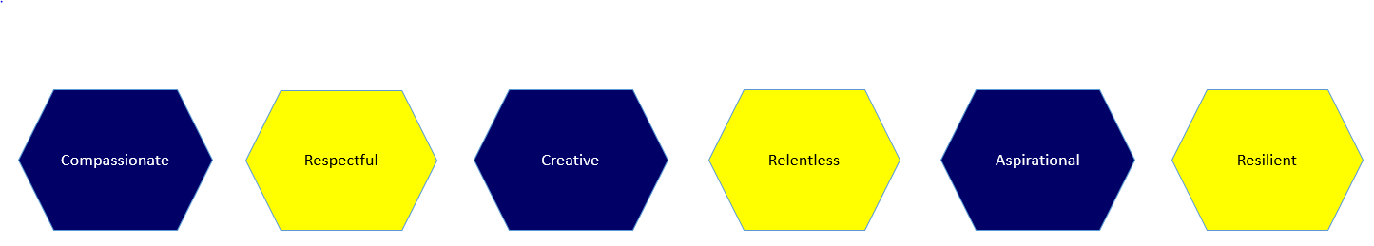

Signed: ……………………………………………………………………. Dated: …………………………………………................