Our Vision:
To develop aspirational learners who strive for excellence academically, creatively and culturally, benefitting from a wide range of opportunities led by inspirational educators.

Shirley High School
Performing Arts College

Striving for Excellence

Job Description:

Post: Science Technician
Reports to: Senior Science Technician
Line Manager: Head of Science

Under the direction/instruction of senior staff: provide general support to staff and students, including preparation, and routine maintenance of resources/equipment; support the overall work of the Science department and to carry out any other tasks as necessary to ensure the efficient running of the Science department.

Areas of responsibility and guidance: To ensure labs and prep rooms are maintained to comply with health and safety regulations, risk assessments and safety checks.

General:

- Assisting the Science Technicians as appropriate;
- Deputising for the Science Technicians as required;
- Liaising daily with the Senior Science Technician to determine priorities and report on problems and solutions.

Main Responsibilities: To support the effective delivery of science education by providing technical support to teaching staff and pupils by:-

- Preparing equipment, chemicals and specimens for practical sessions and examinations, including constructing and setting up equipment as required;
- Preparing equipment, materials, teaching aids for lessons;
- Monitoring the condition of equipment, books, etc;
- Carrying out minor repairs to equipment, e.g. plugs, fuses etc;
- Keeping laboratories, classrooms, the base room, store cupboards and equipment tidy, clean and safe;
- Monitoring supplies and indicating to the Senior Technician when further stock is necessary; checking deliveries; arranging appropriate storage;
- Assisting with the disposal of used / harmful chemicals, specimens etc;
- Assisting with the care of living specimens;
- Making up and ensuring the ready availability of standard solutions and other agents in all appropriate working areas;
- Purchasing and collecting science materials locally;
- Assisting in practical sessions where required;
- Maintaining a high standard of cleanliness and tidiness throughout the labs e.g. benches, glassware, sinks etc.

Administration:

- Photocopying as required for both departments;
- Ordering new equipment for both departments;
- Putting up wall displays;
- Book keeping for budget.

Support for the School:

- Being aware of and complying with policies and procedures relating to child protection, health, safety and security and confidentiality, reporting all concerns to an appropriate person;
- Being aware of and supporting difference and ensure all pupils have equal access to opportunities to learn and develop;
- Contributing to the overall ethos/work/aims of the school;
- Appreciating and supporting the role of other professionals;
- Attending relevant meetings as required;
- Participating in training and other learning activities and performance development as required;
- Occasional class cover supervision for absent staff.

Personal Qualities:

- Reliable and conscientious pastoral leader with high expectations in line with the school;
- Demonstrate great communication skills with all within the school community;
- Neat appearance in line with the school policy;
- Ability to work as part of a successful team and work effectively under pressure;
- Have the determination and resilience to ensure that all students are challenged in all aspects of school life.

Think Green:

- Support the school in demonstrating good environmental practice (such as energy efficiency, use of sustainable materials, recycling and waste reduction) wherever possible in day-to-day work.

Safeguarding and Child Protection:

- To reinforce and enforce the school commitment to safeguarding and promoting the welfare of children and young people.
- Uphold the duty of care to ensure that if there are any concerns relating to the welfare or safety of a child they are immediately relayed to the Designated Person(s) with responsibility for safeguarding children

Essential | Desirable
Grade C or equivalent in Science (preferably 3 Sciences) | Working knowledge of relevant polices/codes of practice and awareness of relevant legislation
Grade C or equivalent in English & Maths | Thorough, organised and methodical approach to tasks
Ability to prepare equipment and materials for lessons as requested by the Senior Science Technician | Able to prioritise and complete tasks within deadlines set by the Senior Science Technician
Effective use of ICT and other specialist equipment/resources | Ability to relate well to children and adults
Basic knowledge of Science taught in the classroom | Desire and willingness to learn and undertake training as appropriate
Experience in a Science and / or technology environment | Professional attitude and high levels of accuracy and attention to detail
Experience of undertaking a range of Science related tasks | Able to work under pressure in a busy environment

We want all at SHS to believe in and maintain the values of our school:

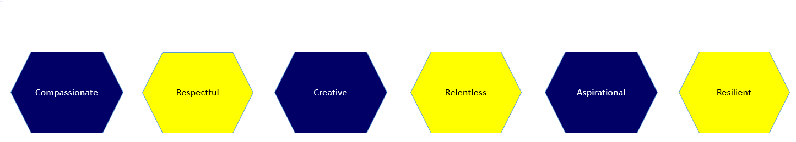

Signed: …………………………………………………………………………. Dated: ………………………………………………………….

