Our Vision:
To develop aspirational learners who strive for excellence academically, creatively and culturally, benefitting from a wide range of opportunities led by inspirational educators.

Shirley High School
Performing Arts College

Striving for Excellence

Job Description:

Post: Director of Faculty – English / Media & Ethics
Line Manager: Deputy / Principal

Areas of responsibility and guidance:

- To oversee the performance of strategic decisions and monitor operations of departments within their assigned faculty
- To lead, plan and strategically manage the departments in the teaching of the subjects within the faculty throughout the school at all phases, that consistently meet and exceed the expectations of the school
- To work with HOD and SLT to support leadership, teaching and learning within the faculty and across the school;
- To attend leadership and additional meetings as required and requested by the Principal;
- To provide clear leadership and lead by example to ensure the vision and values of the school are consistently met;
- To support with extracurricular, enrichment, intervention and catch-up as part of the curriculum and outside of curriculum time, including Saturday school and holiday sessions;
- To support the monitoring and evaluation of teaching and learning within the areas assigned;
- To promote the ethos of inclusion and challenge within the vision and mission statement of the school;
- To support the training of ICT and technological development that will help to improve remote learning and motivate children to learn across the faculty
- To analyse data within specific subjects and faculty for the purpose of recording, monitoring, identifying, evaluating and reporting;
- To contribute to the School Improvement Plan as part of an identified whole school role
- To lead and support whole school initiatives and responsibilities as assigned by the Principal
- To maintain the standards, expectations and policies of the school at all times;
- To create a positive climate of teaching and learning in line with the vision and values of the school;
- To contribute to the School Improvement Plan;
- To be responsible for their specialist Department Improvement Plan and contribute to other departments within their faculty including the process of QA;
- To promote model high professional standards for the entire school community;
- To support the school with cover within the faculty and specific additional operations duties;
- To ensure that the environment for learning within the faculty areas are in line with the school expectations;
- To support the pastoral life of the school including behaviour across the school;
- To support and encourage school and extracurricular opportunities, especially those that enhance the cultural capital of students;
- To maintain the teacher standards assigned to this role;
- Strong knowledge of curriculum, appropriate syllabuses and national curriculum requirements;
- To be accountable for student attainment, progress and outcomes within personal classes and work collaboratively with other departments within the faculty and across the school as deployed by the Principal;
- Keep up to date on the latest research and strategies that can enhance the teaching and learning experience
- Be responsible for the analysis of data to determine areas of strength and development within the faculty.
- Have extensive knowledge and understanding of curriculum and related pedagogy through wider professional networks and the latest research and national policies.
- To ensure that the subject curriculum(s) are a model of progression and is sequenced to ensure all learners make progress and reflect the expectations of the school, national curriculum and specifications (where appropriate);
- To manage budgets and ensure all stock is accounted for and leads to greater progress and opportunities for learners;
- To source other funds for investment, such as external bids.
- To exhaust all strategies, styles and initiatives to help ensure all students achieve at least expected progress and the majority make more than expected.
- To challenge and support colleagues in the student’s best interest.
- To lead on department staff appraisals, including target setting, lesson observations and reviews
- To assist with recruitment within the department;
- Participating in first aid training if required.
- To ensure that marking and feedback meets the expectation of the school throughout the department
- To ensure that homework is set in line with school expectations
- Contribute effectively to the work of the school and the achievement of the school’s key priorities;
- Deploy staff in line with specific job descriptions;
- To liaise with feeder primary schools when appropriate and requested;
- Attend all meetings linked to the role.
- To promote and run CPD within the department and support where appropriate across the school.
- To promote teamwork and motivate staff to ensure effective working relationships.
- Meet with the Principal when required to discuss performance and direction of the department.
- To oversee the organisation of the delivery of all vocational courses at KS4 & KS5.
- To oversee assessment procedures and examinations making sure they are compatible with school policy.
- To organise and lead meetings with staff discussing developments and disseminating information to all involved in teaching within faculties and department
- To work alongside the Exams Officer and SLT on coordinating all exam components for specific courses.
- To ensure that all curriculum maps and medium-term plans, meet changing national and local requirements, recommended guidelines, and frameworks, which enable a high standard of differentiated teaching and challenge;
- To identify education aims and objectives and to review, evaluate and develop the curriculum to meet these aims in coordination with relevant department heads.
- To work with SLT to ensure effective recruitment and retention of students at all phases of learning
- To work with the Work Experience co-ordinator to improve links between course aims and the provision of work experience placements
- To develop the curriculum offered for all key stages so that a variety of pathways are available to meet the needs of the student body.

Personal Qualities:

- Flexible, enthusiastic and innovative towards student and staff development;
- Consistently demonstrate the vision and values of the school
- Reliable, talented and conscientious teacher with high expectations in line with the school;
- Demonstrate great communication skills with all within the school community;
- Neat appearance in line with the school policy; act as a positive role model for students;
- Ability to work as part of a successful team and work effectively under pressure;
- Have the determination and resilience to ensure that all students are challenged in all aspects of school life.
- Have the potential to be a strong senior leader.

Think Green:

- Support the school in demonstrating good environmental practice (such as energy efficiency, use of sustainable materials, recycling and waste reduction) wherever possible in day-to-day work.

Safeguarding and Child Protection:

- To reinforce and enforce the school’s commitment to safeguarding and promoting the welfare of children and young people.
- Uphold the duty of care to ensure that if there are any concerns relating to the welfare or safety of a child they are immediately relayed to the Designated Person(s) with responsibility for safeguarding children.

We want all at SHS to believe in and maintain the values of our school:

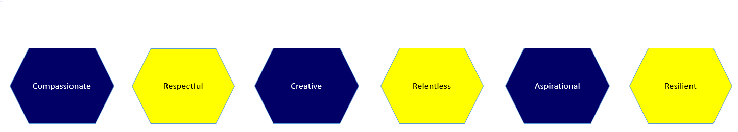

Signed: ……………………………………………………………………………………… Dated: …………………….…………………………

