Our Vision:
To develop aspirational learners who strive for excellence academically, creatively and culturally, benefitting from a wide range of opportunities led by inspirational educators.

Shirley High School
Performing Arts College

Striving for Excellence

Job Description:

Post: Catering Assistant
Line Manager: Catering Manager

Provide a quality service to school pupils and staff within financial and operational guidelines and ensure that a high standard of kitchen hygiene is maintained.

Areas of responsibility and guidance:

- To ensure that cooked and raw foods are kept separate during the preparation/cooking/service process.
- Timely and accurate preparation of routine equipment/resources/materials.
- To ensure the dining areas are kept clean and tidy.
- To refill and replace consumables.
- To report premises/equipment repairs and maintenance issues to the Catering Manager.
- To ensure lights and other equipment are switched off as appropriate.
- To ensure the maintenance of a clean and orderly working environment.
- Serving children and school staff.
- Providing catering for school functions as requested.
- Using the school cashless catering system.
- Attending training sessions/staff briefings as required, possibly outside usual working day
- Ensuring Health & Safety and Food Hygiene regulations are implemented.
- Communication with school staff, lunchtime supervisors and the Principal.
- Promoting the service in the school and participating in special events.
- To ensure the school provided uniform is kept clean and tidy and is worn at all times whilst at work.

Support for the School:

- Being aware of and complying with policies and procedures relating to child protection, health, safety and security and confidentiality, reporting all concerns to an appropriate person;
- Being aware of and supporting difference and ensure all students have equal access to opportunities to learn and develop;
- Contributing to the overall ethos/work/aims of the school;
- Appreciating and supporting the role of other professionals;
- Attending relevant meetings as required;
- Participating in training and other learning activities and performance development as required;

Personal Qualities:

- Reliable and conscientious pastoral leader with high expectations in line with the school;
- Demonstrate great communication skills with all within the school community;
- Neat appearance in line with the school policy;
- Ability to work as part of a successful team and work effectively under pressure;
- Have the determination and resilience to ensure that all students are challenged in all aspects of school life.

Think Green:

- Support the school in demonstrating good environmental practice (such as energy efficiency, use of sustainable materials, recycling and waste reduction) wherever possible in day-to-day work.

Safeguarding and Child Protection:

- To reinforce and enforce the school commitment to safeguarding and promoting the welfare of children and young people.
- Uphold the duty of care to ensure that if there are any concerns relating to the welfare or safety of a child they are immediately relayed to the Designated Person(s) with responsibility for safeguarding children

Essential | Desirable
Understanding of hygiene procedures. | Knowledge of Health & Safety regulations.
Ability to read and implement instructions, such as Health & Safety and Food Hygiene regulations. | Very good organisational skills
uAbility to complete simple financial forms | Ability to use own initiative.
Able to use and clean machinery and light equipment | A positive attitude
Able to encourage children to select a balanced meal. | Experience of catering within an organisation or business
Able to communicate with all kitchen, school staff and pupils
Display and maintain a high standard of personal hygiene
Able to work on own and within a team

We want all at SHS to believe in and maintain the values of our school:

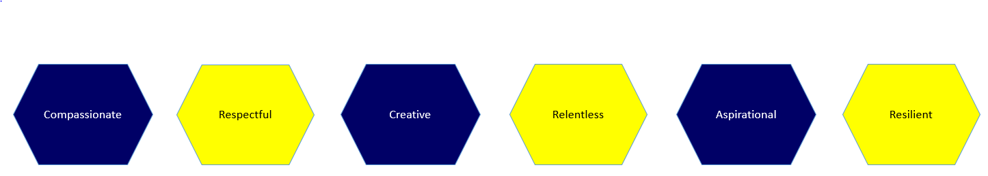

Signature: ……………………………………………………………………… Dated: …………………………………………………….

