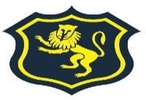
Our Vision:

To develop aspirational learners who strive for excellence academically, creatively and culturally, benefitting from a wide range of opportunities led by inspirational educators.

School leaders are…
“Ambitious, with high expectations of pupils, teachers, and parents throughout the community.”

(Ofsted, December 2022)
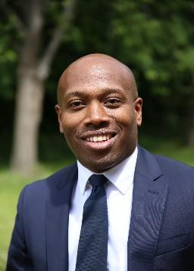

Principal’s Welcome

Welcome to Shirley High School. I am delighted that you have shown an interest in our school, and hope that you share our belief that all our pupils should receive the highest quality education every day.

I am honoured to be the Principal of Shirley High School and extremely proud of the significant improvements we have made as a school. Shirley High School has been under new leadership since 2019. During this time there has been a significant improvement in results, making the school one of the most improved in the borough, substantial investment in our environment to promote pride in all our pupils, and most recently, achieving an Ofsted “Good” in our latest inspection.

We are a school of proud traditions and embrace our fully comprehensive and multicultural learning environment. At Shirley High School we have a clear vision, and our values underpin the daily expectations we have of all within our community. We believe it is our duty to offer all pupils the teaching, learning, and encouragement required to truly fulfil their potential and become successful global citizens.

Our Performing Arts status is part of our identity and contributes not only to the curriculum across all phases, but supports our extensive extra-curricular offer, promoting full immersion within the school community and providing scope for learning and cultural enrichment outside of the classroom.

Shirley High School is on an exciting journey, and we hope it is a journey that you would like to be part of. To fully appreciate the Shirley experience, please do come and visit us to see for yourself what is happening at our school.

Good luck with your application, and I hope to see you soon.
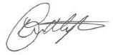
Mr Myton Principal

#weareshirley

