

**Shirley High Academy**

**Performing Arts College**

***Striving for Excellence***

**Job Description:**

Post: Lead Practitioner

Line Manager: SLT

**Areas of responsibility and guidance:**

* To work with the HODs and SLT to support teaching and learning across the academy;
* Actively promote the vision, values and mission of the academy.  Consistently promoting the Shirley Learning Journey and all aspects of being a Shirley Learner;
* To support departments in the teaching of subjects throughout the academy at all phases;
* To develop and plan resources that can be used within departments and throughout the academy that will challenge all students and improve academic outcomes;
* To support in the monitoring and evaluation of teaching and planning within all departments and where directed by SLT;
* To promote the ethos of inclusion and challenge within the vision and mission statement of the academy;
* To maintain the standards, expectations and polices of the academy at all times;
* To support HOD(s) and contribute to Department Improvement Plans;
* To ensure that the environment for learning within all departments is in line with the academy expectations;
* To support the pastoral life of the academy including behaviour within all departments and across the academy;
* To support and encourage academy and extracurricular opportunities, especially those that enhance the cultural capital of students;
* To maintain the teacher standards assigned to this role;
* To teach lessons at all phases that consistently meet and exceed the expectations of the academy;
* Demonstrate strong knowledge of curriculum, appropriate syllabuses  and national curriculum requirements;
* To coach and mentor identified staff and run CPD sessions that will help improve the academy’s learning environment;
* To support SLT where requested on whole academy issues, including the line management of staff and areas as determined by the needs of the academy;
* To improve and be accountable for personal student attainment, progress and outcomes; help to improve outcomes within all departments and the academy;
* Take a lead in planning collaboratively with colleagues in order to promote expected practice;
* Identify and explore links between subjects/curriculum areas in their planning;
* Provide additional sessions designed to improve the outcomes of identified students;
* Support and lead on the academy monitoring and lesson observations expectations;
* To be highly visible within the academy and carry out student supervision as part of the academy schedule for teachers and leaders;
* Keep up to date on latest research and strategies that can enhance the academy’s teaching and learning experience;
* Support in the analysis of data to determine areas of strength and development within all departments;
* To ensure that curriculum maps, plans and resources are in line with academy expectations, national frameworks and there is a clear rationale and sequence to learning;
* To support HODs within their specialist areas to ensure curriculum maps, plans and resources are in line with academy expectations and national frameworks;
* To support HODs in strategic and operational decisions;
* Have extensive knowledge and understanding of curriculum and related pedagogy through wider professional networks and the latest research and national polices;
* Make well founded appraisals of situations upon which they are asked to advise on by SLT.

**Personal Qualities:**

* Flexible, enthusiastic  and innovated towards student and staff development;
* Reliable and conscientious teacher with high expectations in line with the academy;
* Demonstrate great communication skills with all within the academy community;
* Neat appearance in line with the academy policy;
* Ability to work as part of a successful team and work effectively under pressure;
* Have the determination and resilience to ensure that all students are challenged in all aspects of academy life.

**Think Green:**

* Support the academy in demonstrating good environmental practice (such as energy efficiency, use of sustainable materials, recycling and waste reduction) wherever possible in day-to-day work.

**Safeguarding and Child Protection:**

* To reinforce and enforce the academy commitment to safeguarding and promoting the welfare of children and young people.
* Uphold the duty of care to ensure that if there are any concerns relating to the welfare or safety of a child they are immediately relayed to the Designated Person(s) with responsibility for safeguarding children

|  |  |
| --- | --- |
| Essential | Desirable |
| Qualified Teacher Status | Graduate status in subject are or related subject |
| True commitment to high standards | Experience of 11-18 education |
| Track record of improving student performance | Additional teaching qualifications or training |
| Strong classroom management skills | Sound knowledge of current educational developments, including the use of IT |
| Relentless drive for student and personal progress and success | Ability to teach Key Stage 5 |
| Passion for learning and inspiring others | Strong analytical skills with regards leadership and getting the best out of colleagues |
| Respect for all | National leadership qualifications |
| Track record of whole academy positive impact |  |
| Passion for teaching and learning and creating resources to support staff challenge all students |  |

We want all at SHS to believe in and maintain the values of our school:

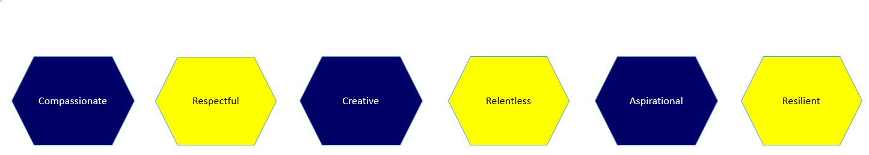

Signed: ………………………………………………………………………………………….. Dated: ………………………………………